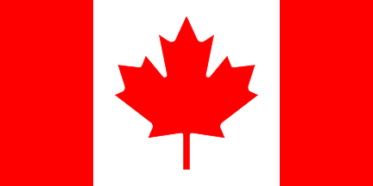
Saturday, September 7, 2019
River Island Arts Park, Woonsocket, RI
Music - Food - Entertainment - Crafts - Trivia

FROM CANADA, "LE VENT DES CANTONS"
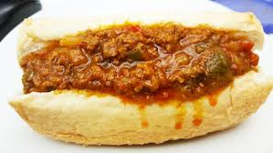Traditional French Meat Pie, Dynamites & more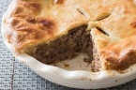

5:30pm - 8:30pm
Holy Trinity Parish Hall (former OLQM)
1409 Park Avenue, Woonsocket, RI
MUSIC - DANCING - ENTERTAINMENT

Dynamites & Beverage- Donation $10
HOSTED BY THE NORTHERN RHODE ISLAND COUNCIL OF THE ARTS
VISIT US AT WWW.NRICA.ORG

